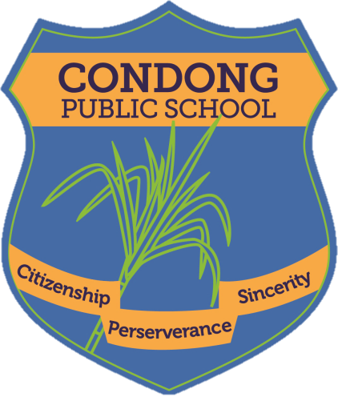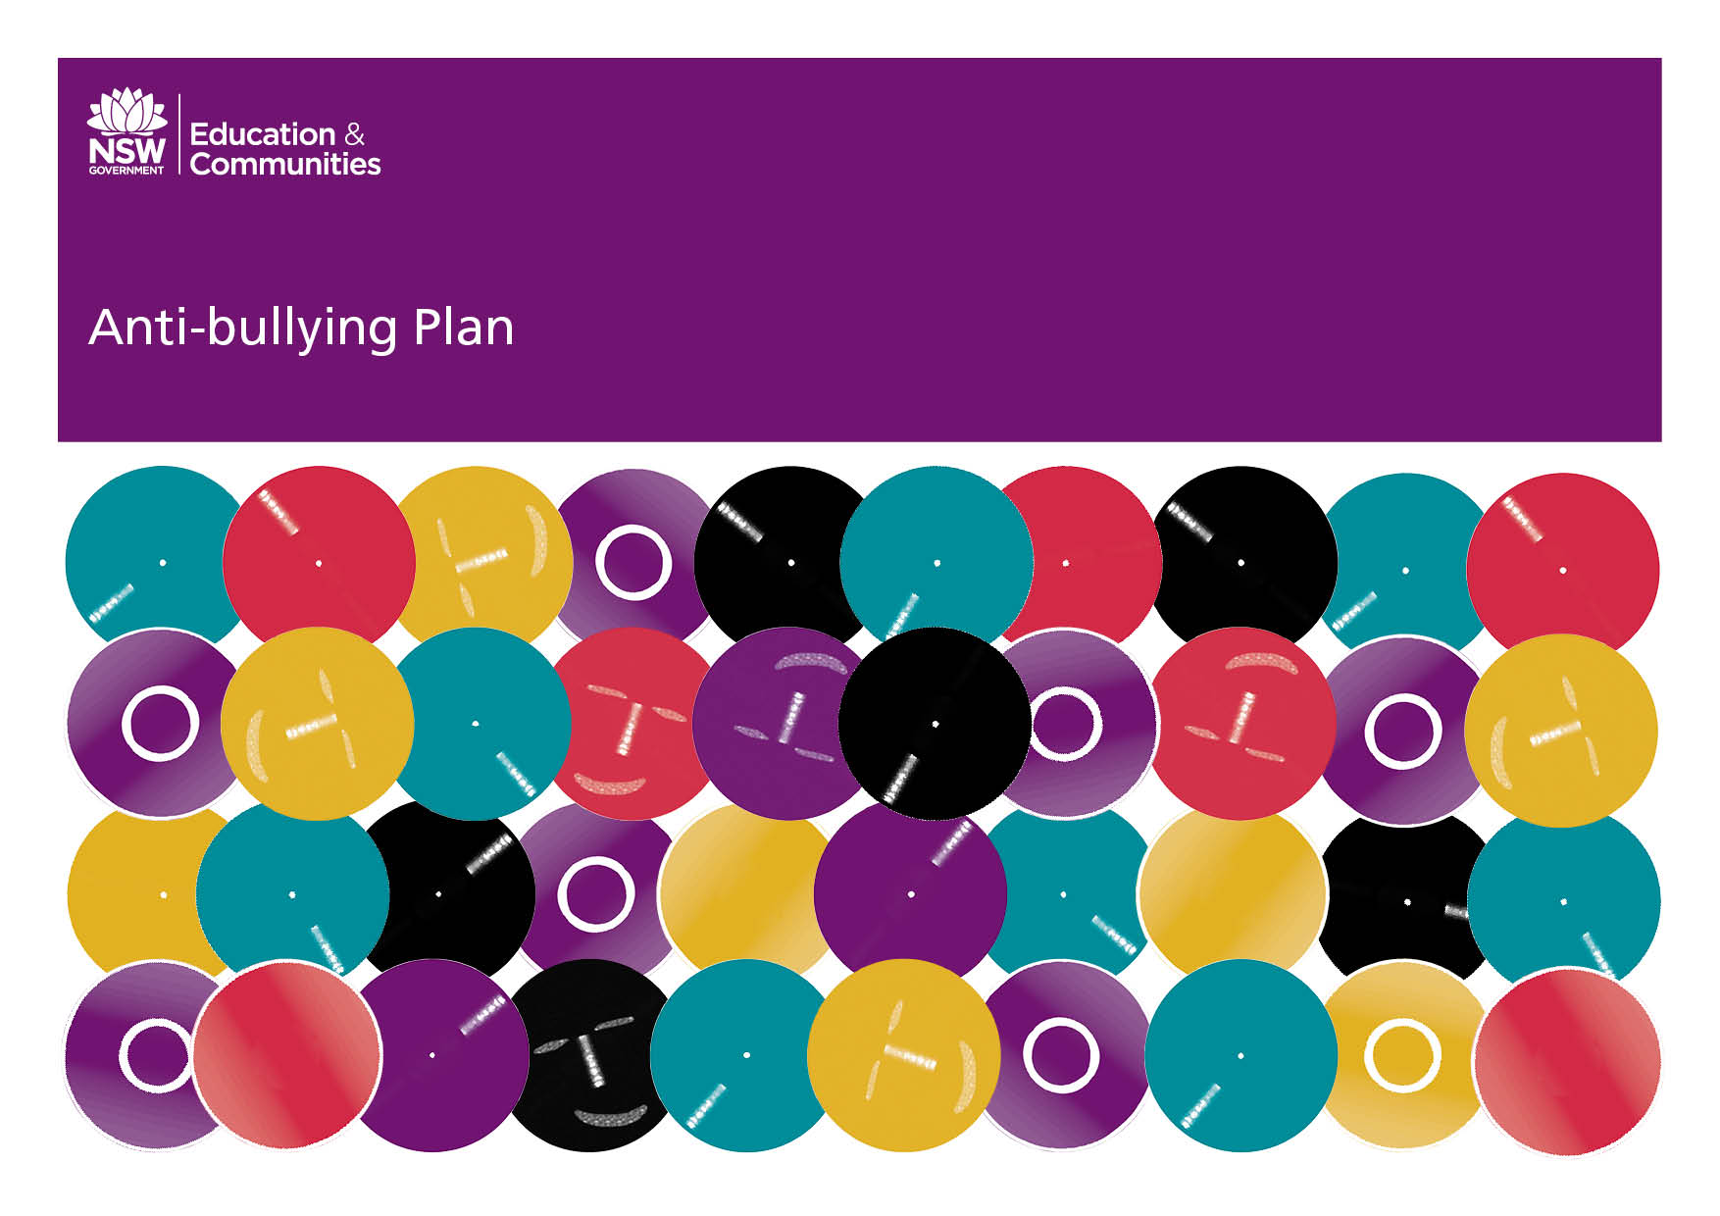**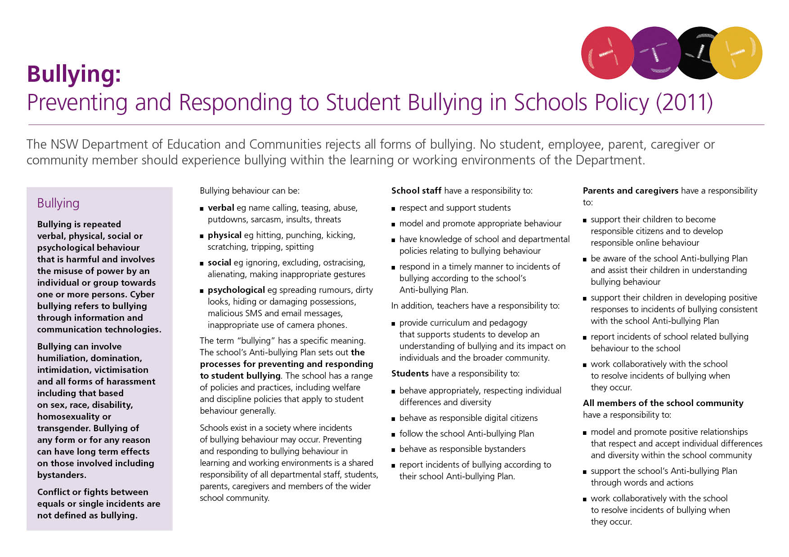 Our School Anti-Bullying Plan**

**Condong Public School - 2018**

Our School Anti-Bullying Plan



This plan outlines the processes for preventing and responding to student bullying in our school and reflects the *Bullying: Preventing and Responding to Student Bullying in Schools Policy*of the New South Wales Department of Education.

Condong Public School is an inclusive environment, where diversity is affirmed and individual differences are respected. Quality education is provided for students to meet their learning needs in a secure, ordered and supportive school environment. Partnership with students, parents, staff and the wider community is considered central to the success of addressing bullying when it occurs in our school community.

* Parents, Staff and students surveyed on their understandings of bullying.
* Surveys results were analysed resulting in a plan being implemented.
* This plan is reviewed annually.

Statement of purpose

Bullying must be taken seriously and is not acceptable in any form. Students and teachers have the right to expect that they will spend the school day free from bullying, harassment and intimidation. Any inappropriate behavior that gets in the way of teaching and learning at the school and interferes with the wellbeing of students will not be accepted.

Protection

Bullying is repeated verbal, physical, social, or psychological behaviour that is

harmful and involves the misuse of power by an individual or group towards one

or more persons. Cyber bullying refers to bullying through information and

communications technologies.

Bullying can involve humiliation, dominations, intimidation, victimisation, and all

forms of harassment including that based on sex, race, disability, homosexuality

or transgender. Bullying of any form or for any reason can have long-term effects

on those involved including bystanders.

Conflict or fights between equals or single incidents **are not defined as bullying.**

Schools exist in a society where incidents of bullying behaviour may

occur. Preventing and responding to bullying behaviour in learning and

working environments is a shared responsibility of all departmental staff,

students, parents, caregivers and members of the wider school

community.

All members of the school community contribute to the prevention of bullying by

modeling and promoting appropriate behaviour and respectful relationships.

[The Complaints Handling Policy](https://www.det.nsw.edu.au/policies/general_man/complaints/resp_sugg/PD20020051.shtml)establishes the standard approach to resolving

complaints, including complaints about the way a reported incident of bullying

has been managed and it is required that it be used in all learning and working

environments of the Department of Education. Reasonable disciplinary action conducted in a reasonable manner does not constitute bullying.

For matters involving bullying which affect departmental employees, refer to the

department’s [Prevention of Bullying in the Workplace Policy](https://detwww.det.nsw.edu.au/policies/staff/oh_s/bullying/PD20050246_i.shtml?level=) (intranet only).

**Responsibilities and delegations**

**Principals**

Principals will ordinarily take reasonable steps to see the school implements an Anti-bullying Plan that:

* Is developed collaboratively with students, school staff, parents, caregivers and the community.
* Includes procedures consistent with DN 10/00225 – Reporting incidents involving assaults, threats, intimidation or harassment and the Incident Reporting Policy
* Includes procedures for contacting the Child Wellbeing Unit, where appropriate
* Includes contact information for the Police Youth Liaison Officer (PYLO) and School Liaison Police Officer (SLPO), where appropriate
* Includes contact information for appropriate support services such as Kids Helpline
* Includes information on departmental appeal procedures and the [Complaints Handling Policy](https://www.det.nsw.edu.au/policies/general_man/complaints/resp_sugg/PD20020051.shtml) is promoted and widely available within the school community and published on any school website
* Is reviewed with the school community at least every three years.

**School Staff**

School staff have a responsibility to:

* Respect and support students
* Model and promote appropriate behaviour
* Have a reasonable knowledge of school and departmental policies relating to bullying behaviour
* Respond in a timely manner to incidents of bullying according to the school’s Anti-bullying Plan.

In addition, teachers have a responsibility to:

* Provide curriculum and pedagogy that supports students to develop an understanding of bullying and its impact on individuals and the broader community.

**Students**

Students have a responsibility to:

* Behave appropriately, respecting individual differences and diversity
* Behave as responsible digital citizens
* Follow the school Anti-bullying Plan
* Behave as responsible bystanders
* Report incidents of bullying according to their school Anti-bullying Plan.

**Parents and Caregivers**

Parents and caregivers have a responsibility to:

* Support their children to become responsible citizens and to develop responsible on-line behaviour
* Be aware of the school Anti-bullying Plan and assist their children in understanding bullying behaviour
* Support their children in developing positive responses to incidents of bullying consistent with the school Anti-bullying Plan
* Report incidents of school related bullying behaviour to the school
* Work collaboratively with the school to resolve incidents of bullying when they occur.

**Implementation Strategies**

* Parents, teachers, students and the community will be aware of the school’s position on anti-bullying. In order for the anti-bullying message to permeate Condong Public School’s culture, information is provided for students, parents, caregivers and teachers to identify bullying behavior.
* The school will adopt a four-phase approach to bullying.

Phase 1:

* Yearly professional development for staff relating to bullying, harassment and proven counter measures
* Community awareness and input relating to bullying, its characteristics and the school’s programs and response.
* To provide programs that promote resilience, life and social skills, assertiveness, conflict resolution and problem solving skills.
* Clarify at the start of each year the school’s policy on anti-bullying.

Phase 2:

* Promote the reporting of bullying incidents by children and/or staff, involving themselves or others.
* Classroom teachers and principal regularly remind students and staff to report incidents of bullying.
* Encourage parents to contact the school if they become aware of a problem.
* Recognise and reward students for positive behaviour and resolution of problems.

Phase 3

* Once identified, within a reasonable timeframe, each bully, victim and witness will ordinarily be spoken with, and incidents or allegations of serious bullying will be fully investigated and documented.
* Students and staff, identified by others, will be informed of allegations within a reasonable time frame.
* Where practical, both bullies and victims will be offered counseling and support.
* If student bullying persists, parents will be contacted and consequences implemented, consistent with the school’s Student Code of Conduct.
* If staff bullying persists, the principal will commence formal disciplinary action.

Phase 4

* Consequences for students will be individually based and may involve:

- exclusion from class or playground

- withdrawal of privileges e.g. excursions and sporting events

- counseling from appropriate agency for both victim and bully.

- school suspension

* Incidents related to bullying will be recorded. Actions taken to address the incidents will be noted.
* A review of bullying incidents will occur during staff meetings and also at the end of each semester in order to identify if additional resources or support is needed. This will encourage students to reflect and think about other strategies they can use.

**Prevention**

Strategies to reinforce positive behavior could include:

* Regular positive reinforcement in classrooms, playground and assemblies. These are encouraging words, actions or emotions that follow a particular behavior of a child. This will therefore cause the child to want to repeat the behavior being reinforced. Always acknowledge positive behavior rather than negative.
* Creative positive environments.
* Classroom based positive development programs
* Drug education program
* You Can Do It Program
* Life Education program
* Child protection program
* Buddy/peer support program
* Developing positive student leadership roles
* Gifted and talented program



**Response**

School is notified of an alleged **serious** bullying incident

Investigation

Clarify what happened. School will take reasonable steps to investigate. If behaviour was bullying then the schools anti-bullying policy will be followed.

All students involved given opportunity to describe and explain their behaviours.

Student who bullied

Recognition of consequences of behaviour. Support in changing behavior.

Bullied student

Development of strategies to build self-esteem and resilience.

.

Parents are contacted.

On-going monitoring.

Processes for dealing with bullying will include:

* Discuss with staff
* Monitor procedures
* School counselor as appropriate
* Parents notified
* Positive behaviours will be role modeled/reinforced

Strategies and programs to support any student who has been affected by or engaged in bullying behavior could include:

* PD/Health program
* Outside agency support
* School counselor
* Positive Behaviour for Learning (PB4L) Program.

**Monitoring, evaluation and reporting requirements**

Principals are responsible for:

* Implementing the policy within the school through staff and

P & C meetings

* The school’s Anti-bullying Plan being published on the schools website.
* Reporting each alternate year to their school community on the effectiveness of the school’s Anti-bullying Plan through the school newsletter.

**Strategies for explicit teaching of dealing with Bullying Behaviour.**

Victims

* Try to stand up for yourself in a positive way. Say “Stop, I don’t like it!”
* Try to talk with the person I am having a problem with.
* Try making a deal or agreement with the other person.
* Ignore the situation and keep playing or working.
* Talk to a friend to get some ideas to make a decision.
* Get help from someone in my support group: family, teacher, friends, school support team, school counselor.
* Walk away and ignore the bully and places where the bullying occurs.

Bystanders

Students should be made aware that witnesses to bullying have a very powerful role to play. Early intervention can defuse conflict situations before bullying sets in or gets out of hand. Therefore the following suggestions have been made:

* Let the person doing the bullying know that what they are doing is bullying
* Refuse to join in with their bullying and walk away
* Support the student who is being bullied
* Ask a teacher or support person for help
* Support his/her friends and protect them from bullying by being there for them

Parents and Caregivers

**Parents and caregivers have an important role when dealing with bullying.**

There are things you can do if you think your child is bullying others or being bullied:

* Talk to your child and encourage them to be open
* Talk to your child’s class teacher/s
* Talk to your child’s school Principal
* Talk to your child’s school’s counselor
* Call the NSW Parent Line – Ph: 1300 1300 52
* Accessing Department of Education resources on the public website about dealing with bullying issues.

Additional Information

Police Youth Liaison Officer – 07 55360999

Murwillumbah Police Station – 02 66729499

Department of Education District Office – 02 66702300

Family and Community Services – 133627

Child Well Being Unit – 02 92699400

School Safety and Response Unit – 1300 363 778

Additional information, resources and support relating to effective anti-bullying strategies can be found at:-

Bullying. No way! www.bullingnoway.com.au

Kids Help Line www.kidshelpline.com.au

Reach Out! www.reachout.com.au

**We promote Resilience and Respect**

***Bullying IS NOT the normal low level childhood disagreements that occur from time to time.***

**Principal’s comment**

This plan was developed in consultation with staff, students and parents.

Brendan Quinn - Principal

Robyn Whyte – Teacher

Kate Borton - Teacher

Michelle Johnston – P & C President

Lara Byrne and Bianca Dench – School Captains

School contact information

Condong Public School

77 McLeod Street

Condong

NSW 2484

Ph: 02 66722390

Fax: 02 66725535

Email: condong-p.school@det.nsw.edu.au

Web: www.condong-p.schools.nsw.edu.au

